Use Case Model
for the
Coffee Maker II System

Submitted by

Dr. David A. Workman
COP 4232

June 4, 2003
Revised: November 13, 2003
by Jennifer Cardona
Table of Contents

Title Page

1.0 System Summary 1
1.1 Document Scope 1
1.2 Motivation and Business Case 1
1.3 Concept of Operation 2
1.4 Coffee Maker Architecture and Interfaces 5
1.4.1 Physical Design and Actor Interfaces 5
1.4.2 Operational States 6

2.0 Use Case Specifications 9
2.1 [Dis]Connect Power Source 9
2.2 Toggle Power Switch 10
2.3 Set Brew Time 10
2.4 Toggle Brew Mode 11
2.5 Set Wall Time 12
2.6 Brew Coffee 13
2.7 Toggle Hot Plate Switch 13
2.8 Fill Coffee Basket 14
2.9 Remove/Replace Coffee Basket 14
2.10 Remove/Insert Carafe 15
2.11 Fill Water Reservoir 16

3.0 System Requirements 17
3.1 Functional Requirements 17
3.2 Non-functional Requirements 18
3.2.1 Safety Requirements 18
3.2.2 Performance Requirements 19
3.2.3 Usability Requirements 19
3.3 Requirements Traceability 20

4.0 Glossary 22

Table of Figures

Title Page

Figure 1.3 Use Case Diagram for Coffee Maker II System 2
Figure 1.4-1. Coffee Maker II System Physical Design 5
Figure 1.4-2 Control Console 6
Figure 1.4-3 Transitions Controlling the Hotplate. 7
Figure 1.4-4 Transitions and Events Controlling the Brew Cycle. 7
Figure 1.4-5 Time Display Control States and Transitions 8
Figure 1.4-6a Brew Timer Control and Transitions 8
Figure 1.4-6b Wall Timer Control and Transitions 8
Figure 2-1. Collaboration Diagram for Set Brew Time 11
Figure 3.3-1 Functional Requirements Traceability Matrix 20
Figure 3.3-2 Non-Functional Requirements Traceability Matrix 21

1.0 System Summary

1.1 Document Scope

This document describes the functional requirements (use cases) and design constraints (non-functional requirements) of the Coffee Maker System as viewed from the perspective of the client, CafAdiksTM Home Products, and the system’s typical end user, the Coffee User. Its purpose is to formally capture and present an operational view of the Coffee Maker II system and to enumerate the system requirements as understood by the developer, COP 4232, Inc.

1.2 Motivation and Business Case

CafAdiksTM Home Products, hereafter referred to as “CafAdiks”, has observed declining sales of its current Coffee Maker system in the last three quarters due to a new line of coffee makers introduced by its competitors within the last year. As a consequence of this sales trend, the Marketing department of CafAdiks conducted a customer satisfaction survey (see Appendix A). The results of this survey (1000 customers responded) clearly indicate that customers are dissatisfied with the lack of features compared with CafAdiks’ competitors. Foremost among the deficiencies cited by customers is the lack of an automatic brewing function (80% of those responding to the survey) enabling the user to set the time of day at which the coffee maker would begin its normal brewing cycle. Another deficiency, earning second place in the customer survey (70% of respondents), is the lack of an external water level indicator, graduated by “number of cups”, showing the user the actual volume of water in the reservoir. A close third to the aforementioned deficiencies is the lack of control over the carafe hotplate (65% of respondents). Customers want the hotplate to automatically turn off (as a safety feature) one hour after the brewing cycle completes. In addition, they want to be able to warm the carafe between brewing cycles, rather than having to heat left-over coffee on the stove or in a microwave oven.

CafAdiks Marketing also conducted a survey of competitors’ coffee making systems and discovered that 75% of our closest competitors have two or more of the top three feature identified as deficiencies of the CafAdiks Coffee Maker. Marketing estimates that if CafAdiks releases a new line of Coffee Makers within the next six months, then sales should stabilize at 60% of market share (this would be down from CafAdiks’ previous market hare of 70%).

To recapture CafAdiks dominant position as producer of coffee delivery systems for home users, CafAdiks Marketing recommends that one or two new features should be added over and above features needed to address the above deficiencies. The new feature set together with an extended warrantee, accompanied by no more than a 30% increase in retail price, should enable CafAdiks to regain its leadership as the premiere coffee maker manufacturer in one year with 80% market share.

The remainder of this section and the next present a functional description and external design of the Coffee Maker II system, the proposed new line of coffee makers designed to achieve the business goals recommended by CafAdiks Marketing.

1.3 Concept of Operation

Figure 1.3 presents a functional model of the envisioned Coffee Maker II system. User-oriented functions (use cases) are identified by round bubbles appearing inside the box denoting the physical and logical boundary of the new system; green bubbles denote new features added in the Coffee Maker II system. All entities shown outside the system box represent actors, that is, independent agents that must interact with the system to accomplish all use cases defined by the diagram. As shown in the figure, there are two actors: the Coffee User and a Power Source.

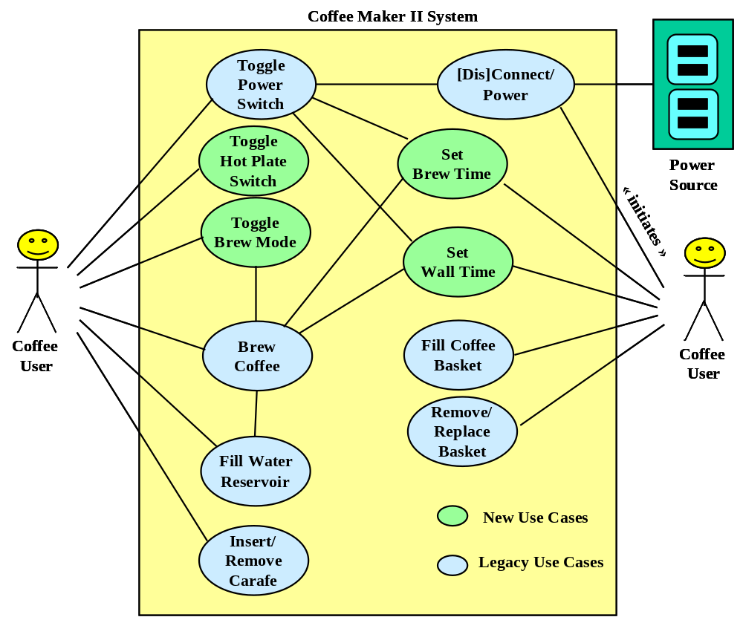

Figure 1.3 Use Case Diagram for Coffee Maker II System

[Para.1] The Coffee User denotes a typical home coffee user. The goal of this actor is to prepare the Coffee Maker II system for its primary function of brewing coffee. There are two mechanisms the Coffee User can use to setup and initiate the brewing function, (1) by setting the brew mode to automatic after setting the brew time, or (2) by setting the brew mode to manual and then pressing the start brew button on the control panel.

[Para.2] Before any capability of the Coffee Maker II system can be activated, the Coffee User must plug the power cord of the Coffee Maker II system into the Power Source ([Dis]connect power). The Power Source must be a standard grounded wall outlet, or the equivalent, delivering 110 Volts of 60-cycle AC electric current. All functions of the Coffee Maker II system shall be disabled (and revert to their default initial status) whenever the Power Source is disconnected.

[Para.3] Functionality of the Coffee Maker II system shall also be controlled via the Power Switch. The Power Switch shall provide the Coffee User a convenient mechanism for enabling (ON position) or disabling (OFF position) all functions of Coffee Maker II (toggle power switch), without having to connect or disconnect the Power Source. The default position of the Power Switch is OFF. The current Power status shall be indicated by a light on the control console of the Coffee Maker II system.

[Para.4] The Coffee Maker II system shall provide an LED device on the control console for providing brew mode status, wall time, and brew time (Hours, Min, AM/PM). Independent status lights shall indicate the On/Off status for the Power Source and Hot Plate.

[Para.5] Whenever the Power status changes from OFF to ON the Coffee Maker II system shall reset to its initial state where manual is selected as the default brewing mode, the hotplate is off, the time display is flashing the default wall time of “12:00 AM”, and the brew time is set to the default of “6:00 AM.” The internal clock will immediately start to update the time display (in a flashing mode) until the Coffee User resets the Hour, Minute, or AM/PM components of the wall time (set wall time).

[Para.6] The Coffee User can manually activate the brew cycle by setting the brew mode to manual (toggle brew mode) and pressing the start brew button on the console (brew coffee).

[Para.7] The Coffee User can view or update the brew time by pressing the auto brew button on the console (set brew time). The Coffee Maker II system responds by displaying the current brew time via the time display. This time can be changed using the Hour, Minute, AM/PM buttons on the console in the same way they are used to set wall time. The new brew time becomes installed when Coffee User presses the (auto brew) button a second time. The brew cycle will automatically begin (brew coffee) when the wall time equals the brew time and the brew mode switch is set to automatic. If the brew mode is manual, the auto brew feature is not activated.

[Para.8] Prior to initiating a brew cycle, the Coffee User must ensure that the water reservoir is filled with water to the proper level (fill water reservoir), that coffee grounds have been placed in the coffee basket (fill coffee basket), and that the Carafe is in its proper position (replace/remove carafe) on the Hot Plate under the Coffee Basket.

[Para.9] A lid on top of the Coffee Maker II system provides access to the Water Reservoir. The water level indicator on both sides of the Water Reservoir is graduated in cup units (6 oz.) giving the Coffee User a clear view of the water level during the filling process. The Water Reservoir is capable of holding a maximum of 72 oz.(12 cups).

[Para.10] The Coffee Basket is used to hold a coffee filter with grounds during the brewing cycle. Water drips from the reservoir into the coffee basket from the top. Brewed coffee drips from the bottom of the basket into the coffee Carafe positioned below. A spring valve at the bottom of the Basket is automatically opened when the Carafe is in the proper position. If the Carafe is removed (remove/replace carafe) during the brewing cycle, the spring valve will close preventing the brewed coffee from dripping onto the Hotplate and onto the floor. This feature avoids an annoying mess should the Coffee User fail to place the Carafe in its proper position to receive the brewed coffee. Since the Basket only holds two cups (12 ozs), it is imperative that the Carafe be quickly returned to its proper place to avoid overflow. Finally, the Basket shall be removable to facilitate easy cleaning (remove/replace basket).

[Para.11] The Carafe shall be designed to hold 10% more than the capacity of the Water Reservoir to ensure overflow will not occur if the Carafe is properly positioned throughout the brewing cycle. The Carafe is also graduated to indicate the number of cups of capacity. It is therefore is the ideal vessel to use in filling the Reservoir.

[Para.12] The Hotplate shall be designed to maintain a coffee temperature of 100ºF for two hours with a full carafe in contact with the heating surface. The Hot Plate shall automatically be set to its On state whenever a brew cycle is initiated. The Hot Plate shall automatically change to its Off state two hours after a brew cycle has completed (without any intervening change in the power status). At any time, the On/Off status of the Hot Plate can be manually controlled by the user via the Hot Plate Switch (toggle Hot Plate Switch).

[Para.13] The default (initial) time mode shall be Wall Time, and its initial value shall be “12:00AM” (midnight). When the Power status changes from OFF to ON, the Wall Time and the wall time indicator shall be displayed on the LED in a flashing mode. The Coffee User can update the Wall Time (only in wall time mode) by pressing the Hour, Minute, AM/PM buttons on the Console until the desired time appears on the LED. Pressing any of the time buttons terminates the flashing mode and updates the LED time display.

1.4 Coffee Maker Architecture and Interfaces

1.4.1 Physical Design and Actor Interfaces

Figure 1.4-1 illustrates the physical design of the proposed Coffee Maker II system.

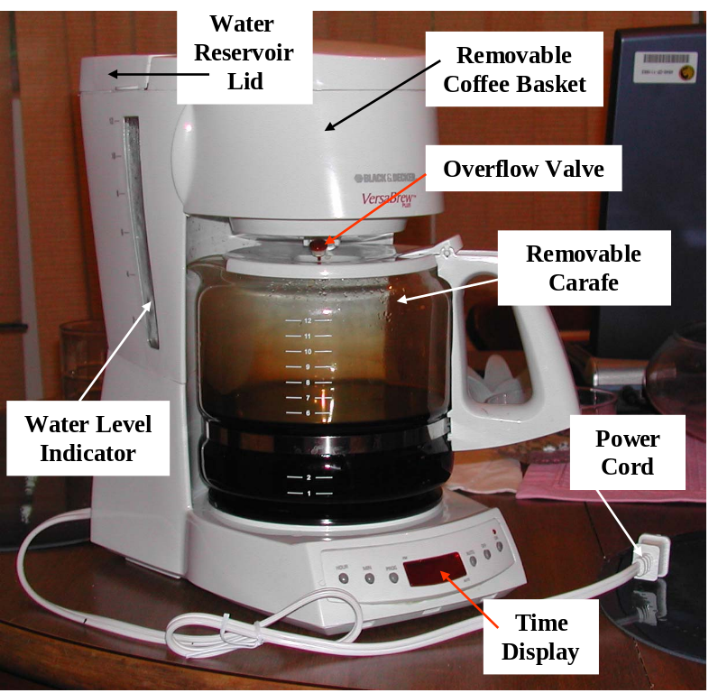

Figure 1.4-1. Coffee Maker II System Physical Design

Figure 1.4-2 illustrates the Control Console design. The three buttons on the left side of the console are used to set the time display by advancing “Hours”, “Minutes” independently until the desired value is reached. Both hours and minutes recycle back to zero when they reach their maximum. The “AM/PM” button is a toggle switch – alternating between “AM” and “PM” each time it is pressed.

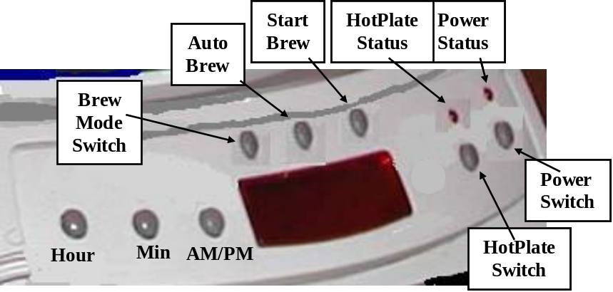

Figure 1.4-2 Control Console

The buttons on the right control the status of the power source and hotplate. These are toggle switches – alternating between “ON” and “OFF” each time the button is pressed. The “ON” condition is indicated by the status lights positioned above each button – they burn “red” when the corresponding switch is in the “ON” position.

The three buttons positioned above the time display control the brew cycle. The Brew Mode button is a toggle switch that determines the method by which the brew cycle is initiated – it alternates between “auto” and “manual” each time the button is pressed. The brew mode is displayed at the top of the time display panel under the Brew Mode button. Brew mode “manual” disables the brew timer and requires pressing the Start Brew button to initiate the brew cycle. When the brew mode is “auto” the Brew Time and the current wall time determine when a brew cycle begins. To set the Brew Time, the “auto brew” button is pressed. This displays the Brew Time on the time display. The time buttons (Hour, Min, AM/PM) can then be used to reset the Brew Time. When the “auto brew” is pressed a second time, the Brew Time is saved and the wall time is re-displayed in the time display panel.

1.4.2 Operational States

The behavior of the Coffee Maker II is determined by the state of several independent components. The Coffee User needs to know and control whether or not the system is “brewing”, whether or not the hotplate in “on”, whether or not the power is “on”, the value of wall time, the value of brew time, and finally, what brew mode the system is in. Several interaction events and conditions trigger changes in the behavior state. These states and the events that trigger transitions between states are defined in this section.
Power-ON: the Power Source is connected AND the Power Switch is in the “ON” position; otherwise the system is in the Power-OFF condition.

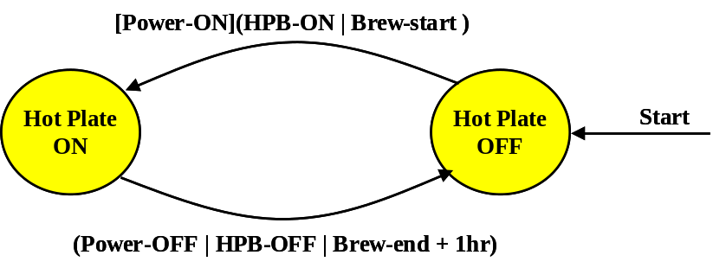

Figure 1.4-3 Transitions Controlling the Hotplate.

Figure 1.4-3 describes the events and conditions that determine whether or not the Hotplate is on. The Hotplate can be “ON” only if the system is in the Power-ON state. The transition to “Hotplate ON” will then occur if either the hotplate button is toggled to the “ON” position (HPB-ON), or the brew cycle has begun. The transition back to the “Hotplate OFF” will occur if a Power-OFF condition arises or the hotplate button is toggled “OFF”, or finally if one hour has elapsed since the end of the last brew cycle. All other system events leave the hotplate in a stable state.

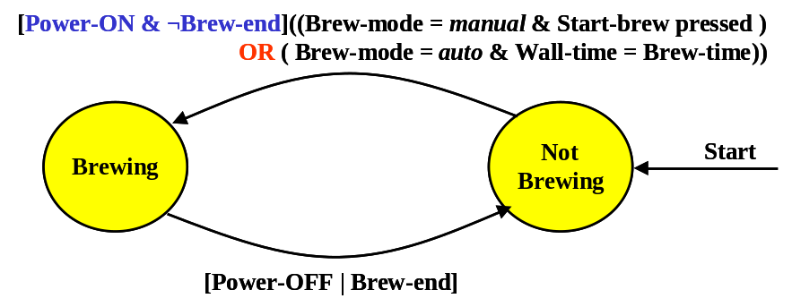
Figure 1.4-4 Transitions and Events Controlling the Brew Cycle.

As with the hotplate, a pre-condition to starting a brew cycle is that the system be in a Power-ON condition and the Brew-end condition is not met (sufficient water in the reservoir). Given this, a brew cycle begins if the Brew Mode switch has been toggled to the manual position and the Start Brew button has been pressed. Alternatively, in auto brew mode, the triggering event is a signal that the Brew Time equals the Wall Time. Brewing terminates if a Power-OFF condition arises or the Brew-end condition holds. The Brew-end condition is true if the water sensor in the water reservoir detects that there is less than one cup (6 ounces) of water volume remaining.
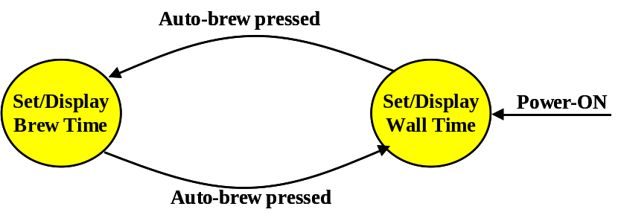

Figure 1.4-5 Time Display Control States and Transitions

The Time Display(TD) contains a digital LED output device that displays the value of the internal wall clock timer or the value of the brew timer depending on the number of times the Auto-brew button has been pressed. While the Power-ON condition holds, an even number of Auto-brew presses (including none) leave the TD device in the “Set/Display Wall Time” state where it takes its input from the Wall Timer, otherwise the TD is in the “Set/Display Brew Time” state where it takes its input from the Brew Timer. These two states also determine the effect of pressing the Hour, Min, and AM/PM input buttons on the Control Console.

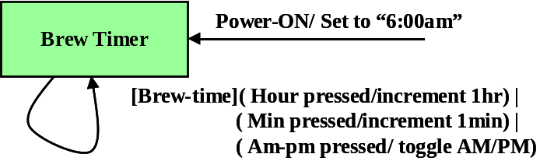

Figure 1.4-6a Brew Timer Control and Transitions

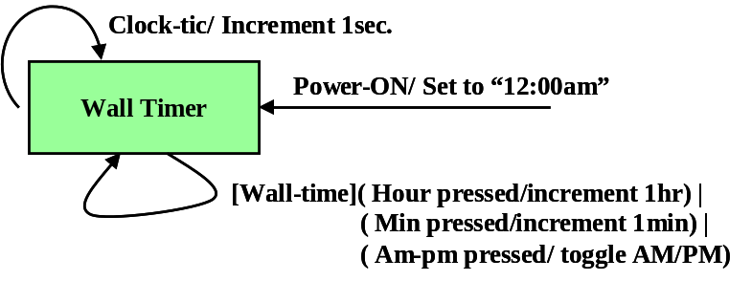

Figure 1.4-6b Wall Timer Control and Transitions

As shown in Figures 1.4-6(a) and 1.4-6 (b), the Brew Timer is set initially to “6:00am” and the Wall Timer is set to “12:00am” when the Power-On condition holds true. The Time Display is in the “Set/Display Brew Time” state, then the Hour, Min, AM/PM buttons enable the Coffee User to change the Brew Timer. Similarly, when the Time Display is in the “Set/Display Wall Time” state, these button enable the Coffee User to change the Wall Timer. The primary difference between these two timers is that the Wall Timer is continuously incremented every second while the Power-ON condition holds.

2.0 Use Case Specifications

This section gives the detailed specifications for a subset of the use cases described above. In the Use Case Model, use case specifications should document the interaction scenarios between the Coffee User, the Power Source, and the Coffee Maker II System, they should not describe the interaction between internal components of the Coffee Maker II System. Pre-conditions and Post-conditions should be expressed in terms of interaction events with one or more actors and/or the system states defined in Section 1.4. Collaboration diagrams should depict interactions between actors and the system boundary – that is, system interface features. Collaboration diagrams, like scenarios, should not describe interactions between internal system components that might be precipitated as a result of actor interactions. Only in the Analysis and Design Models should use case specifications document internal system behavior.

2.1 [Dis]Connect Power Source

ID: UC1

Purpose
The purpose of the (Dis)Connect Power Source use case is to provide (or remove) electrical power to the Coffee Maker II system.

Pre-conditions
Connect: The power cord plug is not connected to an electric wall outlet with ground socket, or any other source of electric power.
Disconnect: The power cord plug is connected to an electric wall outlet and is supplying electrical power to the Coffee Maker II system.

Scenario (Connect)
1. The Coffee User grasps power cord by its plug end.
2. The Coffee User inserts cord plug into a wall outlet with ground socket.

Alternate Scenario (Disconnect)
1. The Coffee User grasps power cord by its plug end.
2. The Coffee User removes the plug from the wall outlet.

Post-condition
The mating of the power plug with the wall outlet has been reversed from its relationship defined by the Pre-condition.

2.2 Toggle Power Switch

ID: UC2

Purpose
The purpose of the Toggle Power Switch use case is to turn ON/OFF power to the Coffee Maker II System.

Pre-conditions
The Power Source is connected to the Coffee Maker II system.

Scenario
- The Coffee User reverses the position of the Power Switch.
2a. If the Power Status Light was ON, it is turned OFF by Step 1.
2b. If the Power Status Light was OFF, it is turned ON by Step 1.
2b.1 Brew mode is reset to its default status and displayed on the LED.
2b.2 The Hot Plate is reset to its default status and indicated by the Hot Plate
Status Light.
2b.3 The Brew Time is reset to its default.
2b.4 The Wall Time is reset to its default and is displayed in flashing mode on the LED.

Alternative Scenario
If the Power Source is not connected, then this use case has no effect.

Post Condition
The Power Status Light has reversed its state. If the new Power Status is ON, then the Coffee Maker II system is reset to its default (initial) state and is displayed by the LED and console status lights; otherwise, all console status lights and the LED display lose power and show “off”.

2.3 Set Brew Time

ID: UC3

Purpose
The purpose of the Set Brew Time use case is to set the Brew Time in preparation for activating the automatic brew function.

Pre-conditions
The Power Status is ON. The Wall Time value and indicator is displayed on the LED.

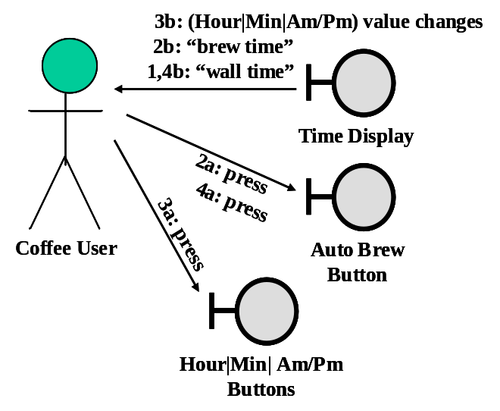
Figure 2-1. Collaboration Diagram for Set Brew Time

Scenario (See Figure 2-1)

    - This use case starts when the Coffee User presses the Auto Brew button on the Control Console.
    - The LED displays the “brew time” indicator (“wall time” indicator is no longer visible) and the current value of Brew Time.
    - The Coffee User repeats zero or more of the following actions until the desired Brew Time appears on the LED.
(a) Press the Hour button until the LED shows the desired value of hours.
(b) Press the Min button until the LED shows the desired value of minutes.
(c) Press the AM/PM button until the LED shows the desired value “am” or “pm”.
    - Coffee User presses the Auto Brew button on the Control Console.
    - The LED panel displays the “wall time” indicator (“brew time” indicator is no longer visible) and the updated value of Wall Time.

Post-condition
The LED displays Wall Time and indicator, and the internal value of Brew Time has been updated as described in Step 3. The Power Status is still in the ON.

2.4 Toggle Brew Mode

ID: UC4

Purpose
The purpose of the Toggle Brew Mode use case is alternate the Brew Mode between its two values of automatic and manual.

Pre-conditions
The Power Status is ON. The LED displays the current status of Brew Mode and the current value of Wall Time.

Scenario
- The Coffee User presses the Set Brew Mode button.
2a. If the Brew Mode indicator shows manual on LED before Step 1, then it shows automatic, after Step 1.
2b. If the Brew Mode indicator shows automatic on LED before Step 1, then it shows manual, after Step 1.

Post Condition
The Brew Mode status on the LED has changed its value. The current value of Wall Time and its indicator continue to be displayed on the LED.

2.5 Set Wall Time

ID: UC5

Purpose
The purpose of the Set Wall Time use case is to set the value of Wall Time displayed on the LED.

Pre-conditions
The Power Status is ON. The Wall Time indicator and value are displayed on the LED.

Scenario
- The Coffee User repeats zero or more of the following actions until the desired Wall Time appears on the LED.
(a) Press the Hour button until the LED shows the desired value of hours.
(b) Press the Min button until the LED shows the desired value of minutes.
(c) Press the AM/PM button until the LED shows the desired value “am” or “pm”.

Post-condition
The LED shows the desired value of Wall Time and its indicator.

2.6 Brew Coffee

ID: UC6

Purpose
The purpose of the Brew Coffee use case is to initiate the Brew Cycle.

Pre-conditions
The Power Status is ON. The Coffee Basket holds coffee grounds and is in its “closed” position. The Water Reservoir holds one or more cups of water. The Carafe is in its proper position on the Hot Plate under the Coffee Basket.

Scenario
1a. The Brew Mode = manual and the Coffee User has pressed the start brew button.
1b. The Brew Mode = automatic and the value of Wall Time equals the value of Brew Time.
2. The LED indicates the brew cycle has started. The Hot Plate and status light are turned ON.
3. The Coffee Maker II system executes the brew process by heating water from the Water Reservoir and delivering it to the Coffee Basket where it filters through and bleaches the coffee grounds. From the Coffee Basket, it flows into the Carafe through a pressure valve that automatically shuts off when the Carafe is removed.
4. The brew cycle (Step 3) completes when the Water sensor detects the Water Reservoir is empty. The LED is updated to indicate the brew cycle has completed.

Post Condition
The brew cycle is complete. The Water Reservoir is empty. The Carafe holds the brewed coffee. The Hot Plate and status indicator are ON (unless manually turned off by Coffee User during the brew cycle).

2.7 Toggle Hot Plate Switch

ID: UC7

Purpose
The purpose of the Toggle Hot Plate Switch use case is to toggle power to the Hot plate.

Pre-conditions
The Power Switch is ON position.

Scenario
- The Coffee User changes the position of the Hot Plate Switch.
2a. If the Hot Plate is ON before Step 1, it is OFF afterward.
2b. If the Hot Plate is OFF before Step 1, if is ON afterward.
2b.1 An internal count-down timer is set to turn the Hot Plate OFF after
a time delay TBD (two-hours).

Post Condition
The Hot Plate Status light shall indicate the new status of the Hot Plate.

2.8 Fill Coffee Basket

ID: UC8

Purpose
The purpose of this use case is to enable the Coffee User to add coffee grounds and a filter prior to execution of the Brew Coffee use case.

Pre-conditions
The Coffee Maker II system is not currently executing use case UC6 (Brew Coffee).

Scenario
- The Coffee User swings the Basket into the open position.
- The Coffee User adds a filter to the bottom of the Basket.
- The Coffee User places coffee grounds in the Basket.
- The Coffee User swings the Basket back to its closed position.

Post Condition
The Coffee Basket contains coffee grounds (and a filter) and is in its closed position for brewing.

2.9 Remove/Replace Coffee Basket

ID: UC9

Purpose
The purpose of the Remove/Replace Coffee Basket use case is to enable the Coffee User to clean the Coffee Basket and optionally add coffee grounds and a filter prior to execution of the Brew Coffee use case.

Pre-conditions
The Coffee Maker II system is not currently executing use case UC6 (Brew Coffee).

Scenario
- The Coffee User detaches the Basket from Coffee Maker II system.
- The Coffee User cleans the Coffee Basket and/or adds a coffee filter and grounds to the Coffee Basket.
- The Coffee User re-attaches the Coffee Basket to the Coffee Maker II system.
- The Coffee User ensures the Coffee Basket is in its closed position.

Post Condition
The Coffee Basket is in its closed position for brewing.

2.10 Remove/Insert Carafe

ID: UC10

Purpose
The purpose of the Remove/Insert Carafe use case is to remove the Carafe for cleaning prior to executing the Brew Coffee use case. To remove the Carafe during the Brew Coffee use case to pour a cup of freshly brewed coffee.

Pre-conditions
The Carafe is in its proper position on the Hot Plate under the Coffee Basket. The Coffee Basket is in its closed position.

Scenario
- The Coffee User removes the Carafe from its position under the Coffee Basket.
- The spring valve on the Coffee Basket closes the coffee exit orifice at the bottom of the Basket.
- The Coffee User performs a cleaning activity applied to the Carafe or, perhaps pours freshly brewed coffee into another container.
- The Coffee User replaces the Carafe in its normal position on the Hot Plate under the Coffee Basket.
- The spring valve on the Coffee Basket opens to allow brewed coffee (if any) to flow from the Basket into the Carafe.

Post Condition
Same as the Pre-conditions.

2.11 Fill Water Reservoir

ID: UC11

Purpose
The purpose of the Fill Water Reservoir use case is to add water to the Water Reservoir in preparation for the Brew Coffee use case.

Pre-conditions
The Water Reservoir must not be completely filled.

Scenario
- The Coffee User places the Reservoir lid in the open position.
- The Coffee User pours water into the Reservoir until the desired water level appears on the external gage.
- The Coffee User places the lid of the Reservoir in the closed position.

Post Condition
The Water Reservoir is not empty.

3.0 System Requirements

The requirements, both functional and non-functional requirements, for the Coffee Maker II system are summarized in this section. These requirements have been elicited from the following sources.

- This document, sections 1.0 and 2.0.
- Private interviews with Dr. David Workman, Senior Scientist for CafAdiksTM, Inc.

3.1 Functional Requirements

Req ID | Description | Section/  Para.
F1 | The Coffee Maker II system shall brew coffee, that is, produce hot liquid coffee by blanching coffee grounds with hot water. | [1]1.3[Para.1]  2.6
F2 | The Coffee Maker II system shall provide two modes for activating the brew cycle: (a) manual, and (b) automatic. The automatic mode shall be controlled by a time mechanism that permits the Coffee User to specify the time of day in Hours/Minutes AM/PM at which the brew cycle shall be activated (when the Power is ON). | [1]1.3[Para.1]  [Para.6]  [Para.7]  2.3,2.4
F3 | The Coffee Maker II system shall be powered by standard 110V house current via grounded 3-prong plug and power cord. | [1]1.3[Para.2]  [2]
F4 | The Coffee Maker II system shall provide a Power Switch that provides a convenient mechanism for disabling/enabling the Power Source and resetting the CM-II to its default settings without having to unplug the Coffee Maker from the Power Source. | [1]1.3[Para.3]  [Para.5]  [2]
F5 | The Coffee Maker II system shall provide an LED for displaying time and status information to the Coffee User. In particular, the time shall be displayed in Hours and Minutes, AM or PM, and with an indicator designating whether the time value is brew time or wall time. The Brew Mode (automatic or manual) and the brew status (brewing or not) shall also be displayed on the LED. | [1]1.3[Para.4],  [Para.6]  1.4.1,2.3,2.4,  2.5,2.6
F6 | The Coffee Maker II system shall provide a status indicator light on the Console for Power (ON/OFF). | [1]1.3[Para.3]
F7 | The Coffee Maker II system shall provide a status indicator light on the Console for the Hotplate (ON/OFF). | [1]1.3[Para.12]  1.4.1
F8 | The Coffee Maker II system shall provide an interface for setting Brew Time. | [1]1.3[Para.5]  [Para.7]
F9 | The Coffee Maker II system shall provide an interface for setting Wall Time. | [1]1.3[Para.5]  [Para.13]
F10 | The Coffee Maker II system shall provide a convenient mechanism for filling the Water Reservoir prior to executing the brew cycle. | [1]1.3[Para.8]  [Para.9]
F11 | The Coffee Maker II system shall provide a convenient mechanism for adding coffee grounds and a filter to the Coffee Basket prior to executing the brew cycle. | [1]1.3[Para.8]  [Para.10]
F12 | The Coffee Basket of the Coffee Maker II system shall be removable for cleaning. | [1]1.3[Para.8]  [Para.10]
F13 | The Coffee Maker II system shall provide independent manual control over the Hotplate that maintains a heat source to the Carafe when filled with brewed coffee. | [1]1.3[Para.12]
F14 | The Hotplate of the Coffee Maker II system shall be controlled automatically by the brew cycle (turn ON), and by a two-hour count-down timer that shuts OFF the Hotplate. | [1]1.3[Para.12]

3.2 Non-functional Requirements

The design constraints fall into three categories: safety, performance, and usability. The requirements for each of these categories are enumerated in this section as they are currently understood at the date of publication of this document.

3.2.1 Safety Requirements

Req ID | Description | Source
C1 | Power Cord is a three-pronged plug to ensure proper grounding through the Power Source. | [1]1.3[Para.2]
C2 | The Hot Plate shall automatically turn OFF after two hours of continuous use in the ON state. | [1]
C3 | The Coffee Basket shall automatically shuts off the flow of brewed coffee when the Carafe is removed from its position on the Hot Plate. As a safety feature this requirement reduces the potential for overflow water causing damage to the environment as well as the electrical components of the Coffee Maker II itself. This is also a convenience to the Coffee User by permitting the Carafe to be removed for a brief time period (early cup of coffee) and replacing it before the Coffee Basket capacity is exceeded. | [1]
C4 | The electrical components shall be encased in water tight compartments so that the base of the Coffee Maker II can be submerged in water (for cleaning) without causing electrical faults, or without endangering the Coffee User with electric shock. | [2]

3.2.2 Performance Requirements

Req ID | Description | Source
C5 | The Power Source shall provide a grounded source of 110 Volt AC current. | [1]
C6 | The power cord shall be made of break resistant and cut resistant non-conductive material such as rubber or plastic. | [2]
C7 | The brew capacity of the water reservoir shall be 12, 6-ounce cups. The capacity of the carafe shall be 10% larger than the reservoir capacity. | [1]1.3  [Para.9]  [Para.11]
C8 | The brew temperature of the water shall be between 150o – 175o Fahrenheit. | [2]
C9 | The Coffee Basket shall be removable for ease of cleaning. | [1]
C10 | The weight of the Coffee Maker II system shall not exceed 2.5lb. | [2]

3.2.3 Usability Requirements

Req ID | Description | Source
C11 | The water reservoir shall have an external, graduated volume indicator (in cups) on both sides to facilitate filling the reservoir to the desired level. | [2]
C12 | The Control Console shall be easy to read and understand so that 85% of the Coffee Users will not require a user manual to operate the Coffee Maker II. | [2]

3.3 Requirements Traceability

Use Cases
Requirements |  | UC₁ | UC₂ | UC₃ | UC₄ | UC₅ | UC₆ | UC₇ | UC₈ | UC₉ | UC₁₀ | UC₁₁
Requirements | F₁ |  |  |  |  |  | X |  | X |  | X
Requirements | F₂ |  |  |  | X
Requirements | F₃ | X
Requirements | F₄
Requirements | F₅ |  |  | X | X | X
Requirements | F₆ |  | X
Requirements | F₇ |  |  |  |  |  |  | X
Requirements | F₈ |  |  | X
Requirements | F₉ |  |  |  |  | X
Requirements | F₁₀ |  |  |  |  |  |  |  |  |  |  | X
Requirements | F₁₁
Requirements | F₁₂ |  |  |  |  |  |  |  |  | X
Requirements | F₁₃ |  |  |  |  |  |  | X
Requirements | F₁₄ |  |  |  |  |  | X | X

Figure 3.3-1 Functional Requirements Traceability Matrix

Use Cases
Requirements |  | UC₁ | UC₂ | UC₃ | UC₄ | UC₅ | UC₆ | UC₇ | UC₈ | UC₉ | UC₁₀ | UC₁₁
Requirements | C₁ | X
Requirements | C₂ |  |  |  |  |  |  | X
Requirements | C₃ |  |  |  |  |  |  |  |  |  | X
Requirements | C₄
Requirements | C₅ | X
Requirements | C₆ | X
Requirements | C₇ |  |  |  |  |  |  |  |  |  | X | X
Requirements | C₈ |  |  |  |  |  | X
Requirements | C₉ |  |  |  |  |  |  |  |  | X
Requirements | C₁₀
Requirements | C₁₁ |  |  |  |  |  |  |  |  |  |  | X
Requirements | C₁₂ | X | X | X | X | X | X | X | X | X | X | X

Figure 3.3-2 Non-Functional Requirements Traceability Matrix

4.0 Glossary

Control Console: The front face at the base of the Coffee Maker II system consisting of various buttons, the Time Display panel, and various status lights. See Figures 2 and 3.

Liquid Element Display (LED): The square red colored window in the center of the Control Console. See Figures 2 and 3. This display panel shows various status indicators: brew mode (manual | auto), time display mode (wall time | brew time), and AM/PM indicator. It also gives a read-out of the current value of Wall Time or Brew Time as determined by the value of the time display mode indicator.

Coffee Grounds: This refers to the granular substance made from raw coffee beans through a process of grinding. The granules (grounds) are blanched with hot water during the brew cycle to produce hot coffee. Coffee grounds are usually placed in the Coffee Maker II System coffee basket wrapped in a special paper filter that removes undesirable solid by-products of the blanching process and prevents the coffee grounds themselves from entering the coffee carafe that catches the brewed coffee. Aliases: Grounds, Coffee.

Water Reservoir. This refers to the Coffee Maker II System internal tank that holds water in preparation of executing a brew function. This reservoir has a lid on top of the Coffee Maker II System that is manually opened to facilitate filling. It has an external indicator that displays the water level in the reservoir. Alias: Reservoir.

Carafe: This is a removable glass Pyrex container that serves as a receptacle for hot brewed coffee produced by Coffee Maker II System during its brew cycle. It serves a secondary function of providing a convenient dispensing device for the user when pouring brewed coffee into external containers, such as coffee cups. Finally, it serves a third function of providing a convenient water container for filling the Coffee Maker II System water reservoir in preparation to coffee brewing.

Brew Cycle: This refers to the primary (brew) function of the Coffee Maker II System of brewing coffee by heating water held in the water reservoir and dripping it over coffee grounds held in the coffee basket to produce brewed coffee held in the Coffee Maker II System carafe.

Coffee User: This refers to the actor who interacts with the Coffee Maker II System. This actor can be anyone who is capable of brewing coffee.

Hotplate: This refers to the disk at the base of the Coffee Maker II System. This plate maintains a temperature of 100° Fahrenheit when turned on. The carafe sits on the hotplate and the hotplate is used to keep the brewed coffee warm.

Water Level Indicator: The Water Level Indicator is located along the side of the water reservoir. It indicates how much water is in the reservoir at any time. It is a graduated scale measured in cups. Alias: Indicator

Power Source: This refers to the system that the Coffee Maker II System will receive power from. The power source provides a grounded source of 110 Volt AC current.

Power Switch: This is a switch located on the control console. When the switch is in the ON position, the Coffee Maker II System will receive power from the power source. When the switch is in the OFF position the Coffee Maker II System will now receive power.

Coffee Basket: This is the basket in the Coffee Maker II System that holds the coffee grounds. It is a removable basket that is lined with a filter and then filled with coffee grounds before the brewing process begins.

Coffee Filter: This refers to the liner that is placed between the coffee basket and the coffee grounds. This filter allows only the coffee to pass through to the carafe while the coffee grounds stay in the basket.

Spring Valve: This refers to a valve that automatically shuts off the flow of brewed coffee when the Carafe is removed from its position on the Hot Plate. This reduces the potential for overflow water causing damage to the environment as well as the electrical components of the Coffee Maker II itself. This is also a convenience to the Coffee User by permitting the Carafe to be removed for a brief time period (early cup of coffee) and replacing it before the Coffee Basket capacity is exceeded.

